Project Charter – Executive Summary (Revised with Tuesday Milestones)
Project Title: COVID-19,CDC, and Unemployment Data Warehouse and Reporting Solution
Project Duration: Start week of April 27 – Due June 2 (Tuesday)
Team: J (Project Manager), Suvam (Data Engineer), Gary (BI Developer)

Project Structure

Purpose and Objectives
The project delivers an end-to-end data solution that correlates COVID-19 cases and deaths with unemployment metrics by state and date, using CDC CSV data plus unemployment CSV data.
Objectives:
- Build a relational DB + star-schema data warehouse for CDC COVID and unemployment data.
- Implement repeatable ETL/ELT that ingests CDC CSVs → raw tables → warehouse facts/dims.
- Deliver a Power BI report that shows:
  - COVID cases and deaths by state/date
  - Unemployment by state/date
  - Visual correlations between COVID metrics and unemployment
Success = working, rerunnable pipeline; validated star schema; functional, performant report; and concise docs, with progress anchored to Tuesday milestones.

Scope
In Scope
- Ingest CDC COVID CSV and unemployment CSV data into raw tables.
- Create raw tables:
  - Raw_CDC_Covid, Raw_Unemployment
- Create DW star schema:
  - Dim_State, Dim_Country, Dim_Date
  - Fact_Covid (from Raw_CDC_Covid, grain = state+date)
  - Fact_Unemployment (from Raw_Unemployment, grain = state+date)
- ETL/ELT from CSV → raw → DW (stored procedures/scripts/views).
- Power BI model + report:
  - Top-5 visuals (cases, deaths, unemployment) by state
  - Correlation visuals (COVID vs unemployment over time by state).
Out of Scope
- ML/forecasting, advanced CDC APIs beyond CSVs.
- Full enterprise orchestration/security beyond course needs.

Roles and Responsibilities
- J – Project Manager
Scope, backlog, Tuesday standups/check-ins, risk tracking, test coordination, final demo.
- Suvam – Data Engineer
CDC/unemployment CSV ingestion, raw + DW design, ETL/ELT, performance tuning, technical docs.
- Gary – BI Developer
Power BI model, DAX, visuals, polish, and “how to use this report” guide.

Tuesday-Anchored Plan and Milestones
Assuming work weeks run Wed–Tue, with Tuesdays as standup + milestone days:
Milestone 1 – Tuesday, Week A (first Tuesday after start)
Theme: Kickoff & Design
By this Tuesday:
- Scope & Architecture
  - Scope, success criteria, and non-goals drafted and agreed.
  - High-level architecture documented (Source → Raw → DW → Power BI).
- Data Design
  - Raw tables defined: Raw_CDC_Covid, Raw_Unemployment.
  - DW star schema proposed: Fact_Covid, Fact_Unemployment, Dim_State, Dim_Country, Dim_Date, with state+date grain confirmed.
- Reporting Design
  - Power BI wireframes (Top-5 and correlation visuals) created and approved by J.
- Process
  - Backlog created (Epics: Ingestion, DW, Reporting, Testing/Docs).
  - Tuesday standup/check-in cadence agreed.

Plan and Milestones Reporting
J to update
- Task Overview
- Task Master (see below)
- Additional test graphics
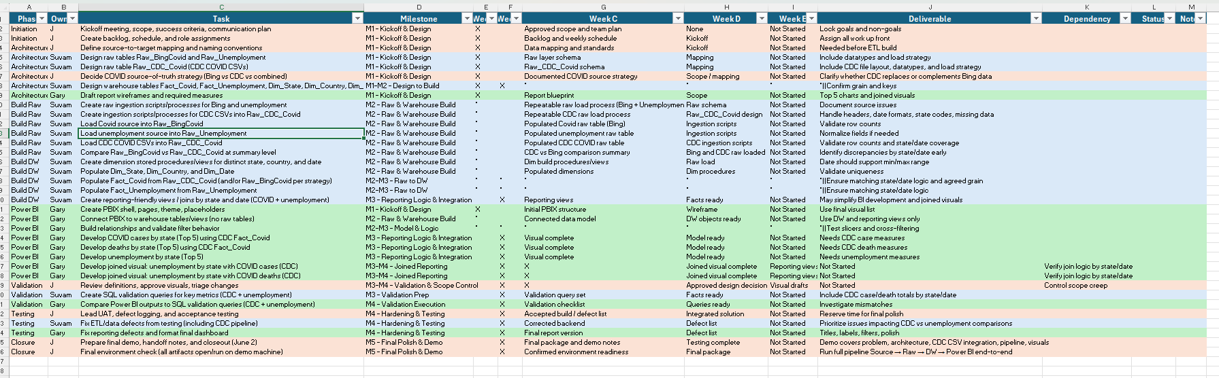
Milestone 1 – Tuesday, Week A (Kickoff & Design)
- Scope & Architecture
  - Scope, success criteria, and non-goals are drafted and agreed.
  - High-level architecture documented (Source → Raw → DW → Power BI).
- Data Design
  - Raw tables defined (at least on paper or DDL draft):
    - Raw_CDC_Covid
    - Raw_Unemployment
  - DW star schema proposed:
    - Fact_Covid
    - Fact_Unemployment
    - Dim_State
    - Dim_Country
    - Dim_Date
  - Grain (state + date) confirmed for fact tables.
- Reporting Design
  - Power BI wireframes created:
    - Top-5 COVID cases by state
    - Top-5 COVID deaths by state
    - Top-5 unemployment by state
    - At least one correlation visual (COVID vs unemployment by state/date)
  - Wireframes reviewed and approved by J.
- Process Setup
  - Backlog created with Epics:
    - Ingestion
    - Data Warehouse
    - Reporting
    - Testing/Documentation
  - Tuesday standup/check-in cadence confirmed.

Milestone 2 – Tuesday, Week B (Raw & Warehouse Build)
- Raw Layer
  - First ingestion of CDC CSVs into Raw_CDC_Covid completed.
  - First ingestion of unemployment CSVs into Raw_Unemployment completed.
- Warehouse Tables
  - Dim_State created and populated once.
  - Dim_Country created and populated once.
  - Dim_Date created and populated for required date range.
  - Fact_Covid created and populated from Raw_CDC_Covid.
  - Fact_Unemployment created and populated from Raw_Unemployment.
- SQL Validation
  - Basic row counts validated for all dims and facts.
  - Distinct state and date counts checked in SQL.
- Power BI Connectivity
  - Power BI model connected to DW schema (not raw).
  - Simple validation visuals created:
    - Row counts
    - Distinct states
    - Distinct dates
  - Power BI counts match SQL counts for these basic checks.

Milestone 3 – Tuesday, Week C (Reporting Logic & Integration)
- ETL & Views
  - ETL from raw → DW refined (state names cleaned, dates aligned).
  - Reporting-friendly views created (e.g., pre-joined state/date views if needed).
- Measures
  - DAX measures implemented for:
    - COVID cases (from Fact_Covid).
    - COVID deaths (from Fact_Covid).
    - Unemployment metrics (from Fact_Unemployment).
    - Top-5 ranking logic.
- Visuals
  - Core visuals built:
    - Top-5 states by COVID cases.
    - Top-5 states by COVID deaths.
    - Top-5 states by unemployment.
    - At least one joined visual: unemployment vs COVID cases by state/date.
    - At least one joined visual: unemployment vs COVID deaths by state/date.
  - Slicers/filters verified to work across joined data.
- Data Consistency
  - Key DAX measures validated against SQL queries from DW.
  - Any discrepancies documented and either explained or fixed.

Milestone 4 – Tuesday, Week D (Hardening, Testing & Documentation)
- Test Plan Execution
  - Formal test plan drafted (data, scenarios, performance).
  - Data validation tests run (SQL vs Power BI).
  - Scenario tests run (various states, date ranges, edge cases).
  - Basic performance checks run (refresh, page navigation).
- Defects & Tuning
  - Critical ETL issues identified and fixed:
    - Incorrect joins or duplicate rows.
    - Bad state/date mappings.
  - Report issues fixed:
    - Wrong aggregations or filters.
    - Broken slicers or interactions.
  - Basic performance tuning applied (indexes/partitioning or similar).
- Documentation (Draft)
  - CDC CSV ingestion steps documented.
  - Source → Raw → DW mapping documented.
  - ETL rerun/recovery procedures documented.
  - “How to use this report” draft written.

Milestone 5 – Tuesday, June 2 (Final Polish & Demo)
- Pipeline Readiness
  - Latest CDC and unemployment CSVs ingested successfully.
  - Full pipeline (Source → Raw → DW → Power BI) runs cleanly.
- Report Readiness
  - All visuals display correct data.
  - Slicers/filters behave correctly and consistently.
  - Visual polish complete:
    - Titles, labels, legends.
    - Number formats and date formats.
    - Colors and basic accessibility (readable, clear).
- Demo & Packaging
  - J can deliver a 10–15 minute demo covering:
    - Problem and objectives.
    - Architecture and CDC CSV integration.
    - Pipeline overview.
    - Walkthrough of key visuals and insights.
  - All deliverables packaged:
    - Scripts/notebooks/DDL for ETL and schema.
    - PBIX file.
    - Final documentation (technical + “how to use”).
  - Final check: everything opens and runs on the machine/environment used for the demo.

Relationship diagram of current data:
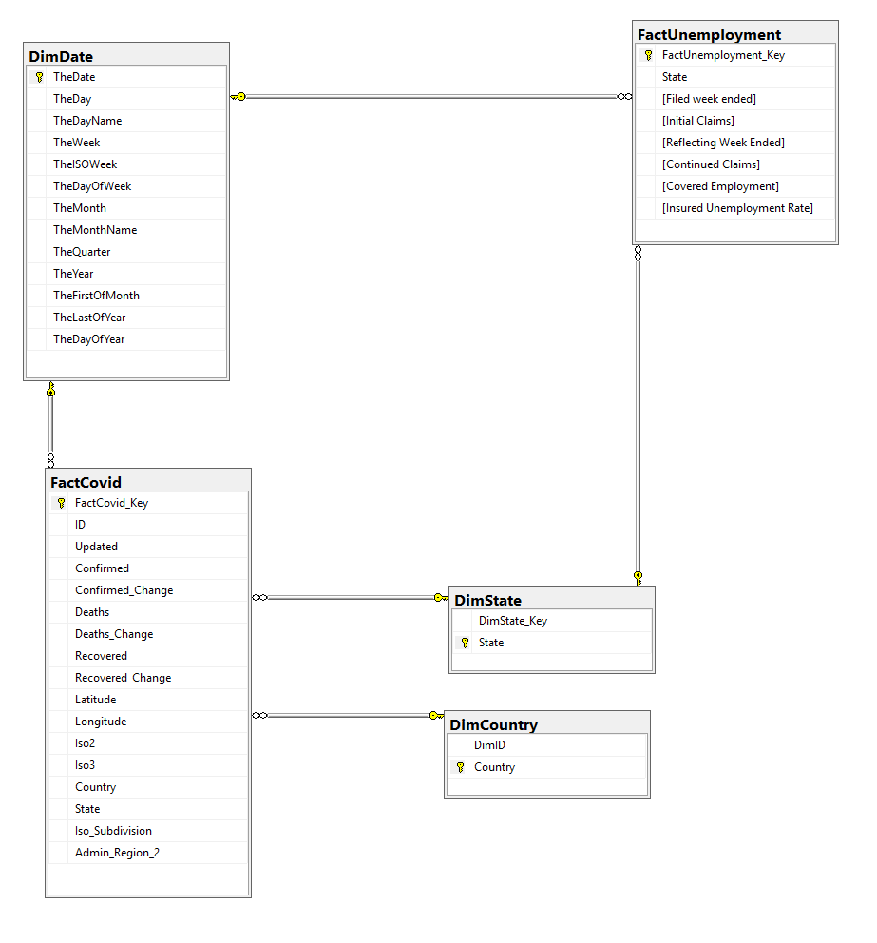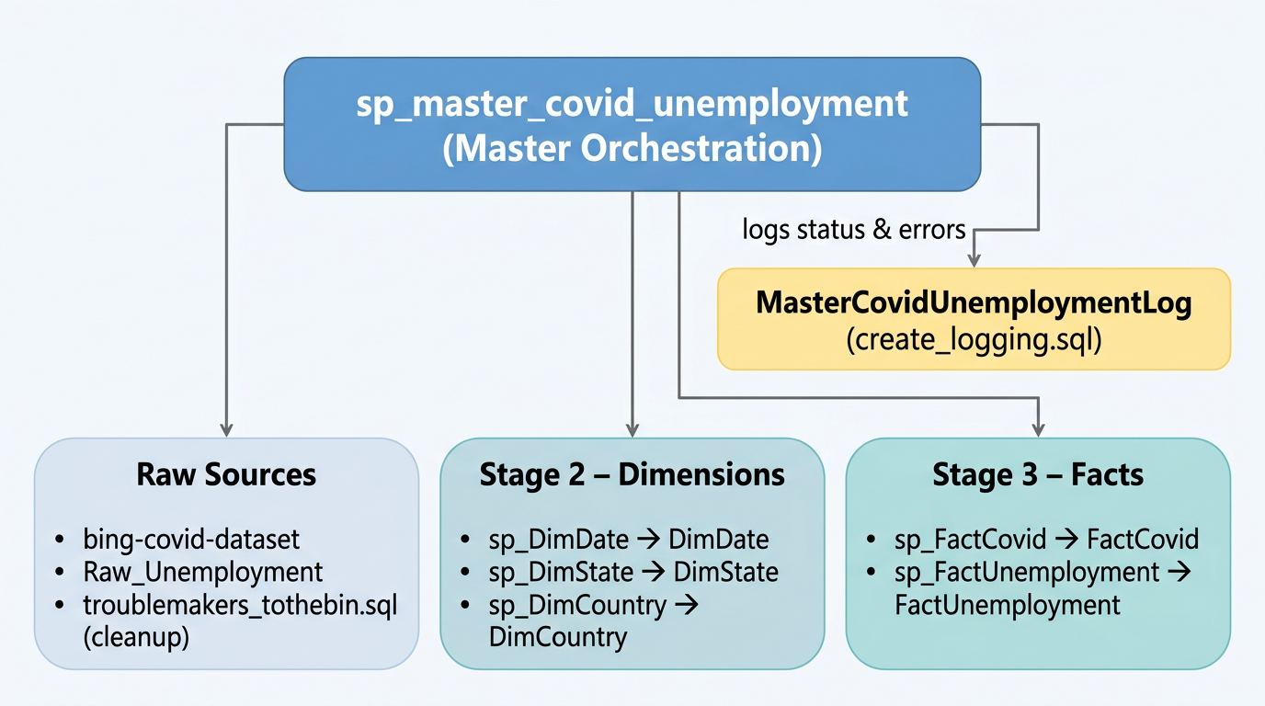

Proposal:
Load sample data from CDC.

Recommended design
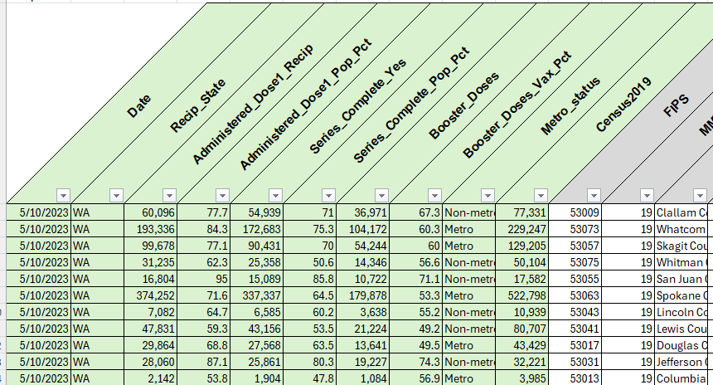
Sample data looks like a state-by-date immunization fact with metrics such as doses, completion, booster counts, metro status, and census population. That fits naturally as a new fact table, likely FactImmunizations, with foreign keys to DimState and DimDate.

What to add
- Create a raw landing table for the source, for example Raw_Immunizations or similar.
- Load the CSV into that raw table first, preserving the source columns as-is.
- Create FactImmunizations and map Recip_State to DimState and Date to DimDate.
- Add the new fact procedure into sp_master_covid_unemployment.sql after the dimension build step, alongside the existing fact procedures
Likely FK additions
The main change is probably foreign keys and load code, not new dimensions.
The fact table can include:
- State FK to DimState
- Date FK to DimDate
- Optional degenerate columns like Metro_status if we want to keep it in the fact rather than model it as a dimension. I would if it had cities but this is metro/non-metro.
Suggested fact structure
A practical FactImmunizations would usually include:
- ImmunizationFactKey as identity PK.
- TheDate or DateKey FK to DimDate.
- State FK to DimState.
- Administered_Dose1_Recip
- Administered_Dose1_Pop_Pct
- Series_Complete_Yes
- Series_Complete_Pop_Pct
- Booster_Doses
- Booster_Doses_Vax_Pct
- Metro_status
- Census2019
- More ?

import pandas as pd
from sqlalchemy import create_engine
import urllib

def getengine():
server = r"uwc-studentsql.continuum.uw.edu\uwcbiddsql"
database = "green_nault"
username = "BICert26"
password = "BICert26"
driver = "ODBC Driver 17 for SQL Server"
params = urllib.parse.quote_plus(
f"DRIVER={driver};SERVER={server};DATABASE={database};UID={username};PWD={password};TrustServerCertificate=yes;"
)
return create_engine(
f"mssql+pyodbc:///?odbc_connect={params}",
fast_executemany=True )

def upload_df(df, table_name, if_exists="replace"):
engine = getengine()
df.to_sql(
table_name,
con=engine,
if_exists=if_exists,
index=False,
chunksize=500,
method=None )

def get_df(fpath):
df =pd.read_csv(fpath, low_memory=False)
df = df.replace('"', '', regex=True)
df.to_csv(fpath)
return pd.read_csv(fpath, low_memory=False)

def main(fpath, table_name):
df=get_df(fpath)
upload_df(df,table_name )

fpath=r'C:\uw_cert\330\Final\COVID-19_US_Vaccinations.csv'
table_name ='raw_us_vaccinations'

#**Running REPLACES table
main(fpath, table_name)

Then run sprocs and it should look something like
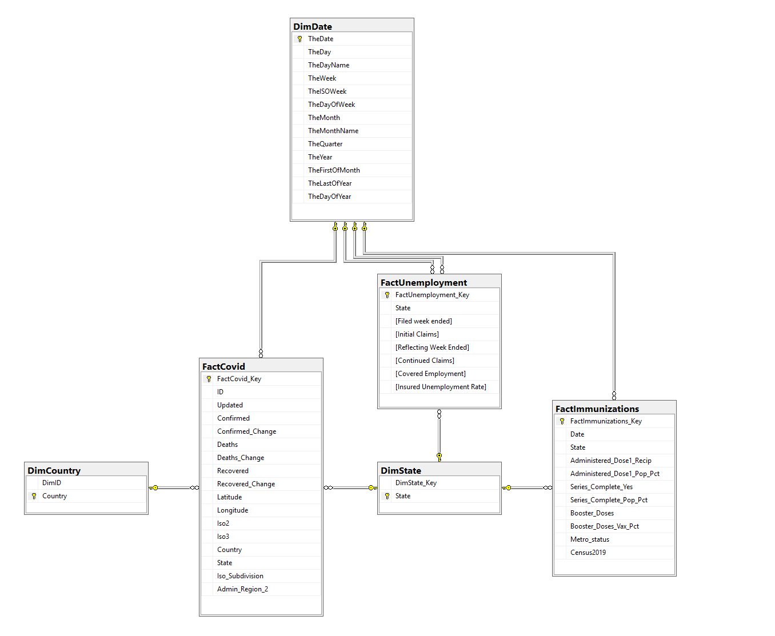
Test upload was ~23k rows.
Full download is in the neighborhood of 635MB. The chunksize should be increased in python, if you use python. I do because the wizards often die on me.

